1. Write a simple program in HTML that displays the heading "HTML defines the content and structure of your website” on the web browser.

ANS: <!DOCTYPE html>

<html lang="en">

<head>

    <meta charset="UTF-8">

    <meta name="viewport" content="width=device-width, initial-scale=1.0">

    <title>Document</title>

</head>

<body>

    <h1>HTML defines the content and the structure of your website</h1>

</body>

</html>

OUTPUT:

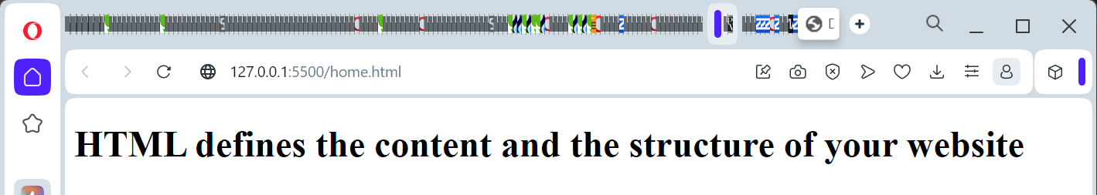

1. Explain the purpose of comments in HTML and provide an example of how to use comment in HTML document

ANS: Comments in HTML serve as non-rendered text that provides information about the code for human readers. They are useful for documenting your code, explaining its purpose, making notes, or temporarily disabling parts of the code without deleting them. Comments are ignored by browsers and do not affect the rendering of the webpage.

Ex: 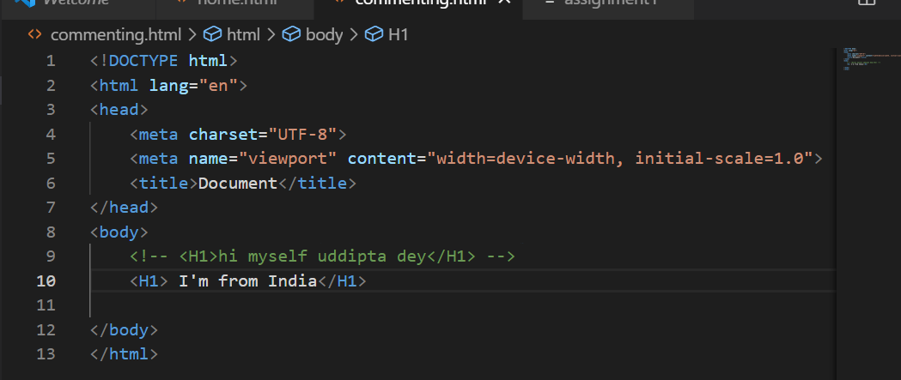

1. Write an HTML program that includes a heading, a paragraph of text, a horizontal line, and a line break.Arrange these elements to create a simple web page layout.

ANS: <!DOCTYPE html>

<html lang="en">

<head>

    <meta charset="UTF-8">

    <meta name="viewport" content="width=device-width, initial-scale=1.0">

    <title>Document</title>

</head>

<body>

    <h1>I'am Indian</h1>

    <p>Lorem ipsum dolor sit amet consectetur adipisicing elit. Voluptatem, perferendis?</p>

    <hr>

    Lorem ipsum dolor sit amet consectetur adipisicing elit. Est architecto accusamus non illo labore nulla.

    <br>Lorem ipsum dolor sit amet consectetur adipisicing elit.

</body>

</html>

OUTPUT: 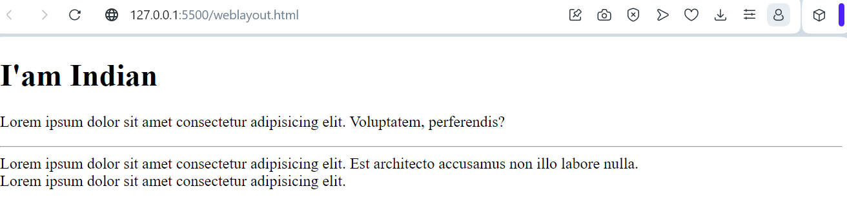

1. Write a short note on Tag and element with an example.

ANS: Tag:

An HTML tag is a snippet of code enclosed within angle brackets ("<" and ">") that defines the purpose and structure of a specific element on a webpage. Tags are used to instruct the web browser how to display the content they enclose. Tags usually come in pairs: an opening tag and a closing tag, with the name of the element enclosed within the tags.

Example of a Tag: <!DOCTYPE html>

<html lang="en">

<head>

    <meta charset="UTF-8">

    <meta name="viewport" content="width=device-width, initial-scale=1.0">

    <title>Document</title>

</head>

<body>

    <h1>I'am Indian</h1>

    <p>Lorem ipsum dolor sit amet consectetur adipisicing elit. Voluptatem, perferendis?</p>

    <hr>

    Lorem ipsum dolor sit amet consectetur adipisicing elit. Est architecto accusamus non illo labore nulla.

    <br>Lorem ipsum dolor sit amet consectetur adipisicing elit.

</body>

</html>

In this example, <p> is the opening tag, and </p> is the closing tag. The content "This is a paragraph tag." is the text within the paragraph element.

Element:

An HTML element is a complete unit that includes an opening tag, content, and a closing tag. It represents a distinct part of a webpage's content or structure. Elements are composed of tags and the content enclosed between those tags.

Example of an Element: <!DOCTYPE html>

<html lang="en">

<head>

    <meta charset="UTF-8">

    <meta name="viewport" content="width=device-width, initial-scale=1.0">

    <title>Document</title>

</head>

<body>

    <h1>I'am Indian</h1>

    <p>Lorem ipsum dolor sit amet consectetur adipisicing elit. Voluptatem, perferendis?</p>

    <hr>

    Lorem ipsum dolor sit amet consectetur adipisicing elit. Est architecto accusamus non illo labore nulla.

    <br>Lorem ipsum dolor sit amet consectetur adipisicing elit.

</body>

</html>

In this example, <p> is the opening tag, "This is a paragraph element." is the content, and </p> is the closing tag.Together, they form the complete <p> element, representing a paragraph of text.

5. What is the DOCTYPE Declaration in HTML?

Answer:The DOCTYPE declaration in HTML is a special instruction placed at the beginning of an HTML document tospecify the version of HTML being used. It ensures proper rendering and parsing by web browsers. The mostcommon declaration, <!DOCTYPE html>, indicates the use of HTML5, the latest version of HTML.